  September 15, 2026
  GLOBAL THEME
  SDG 4: QUALITY EDUCATION
  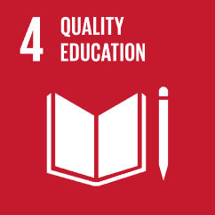
  Hello!
  We are pleased to inform you that we are organising a USO Inter-Schools Fest 2026, at Pilani in Rajasthan. With a very important and urgent theme of SDG 4, we hope to sensitize all teachers and students to the importance of inclusive, equitable and quality education through the various competitions for students.
  Please accept this letter as our invitation to your school to attend the USO Inter Schools Fest, Tirupati.
  We look forward to seeing your delegation on Saturday October 31, 2026 at Birla Balika Vidyapeeth, Pilani, Rajasthan.
  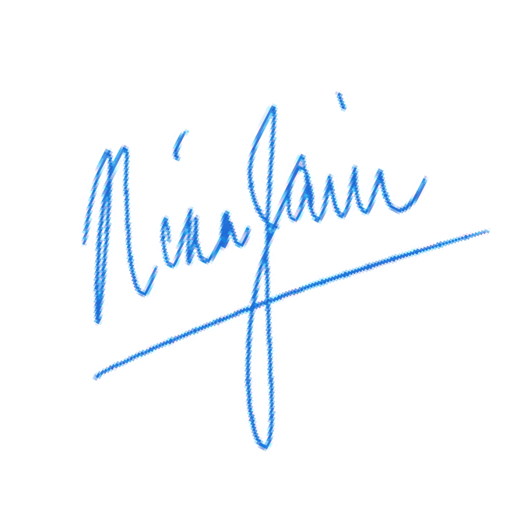
  Best regards,
  Nina Jain
  Secretary General
  ABOUT THE FEST
  The USO Inter-Schools Fest is an occasion for schools in Pilani, to come together, engage in competitions - individually and in groups - and build lasting memories. The event's objective is to promote collaboration, foster healthy competition, and encourage and motivate students to participate in extracurricular activities. We also aim to instill a sense of pride in students for their school.
  DETAILS ON THE FEST
  • Number of competitions: Six
  • Inclusions: Lunch for all delegates.
  • Participation: Max 15 students of Std. 6-12, accompanied by 2 teachers.
  • Registration Fees: Rs. 750 per school (include 1 year USO membership valid till 31 March, 2027)
  • For details: usoindia.org
  ABOUT USO
  United Schools Organisation of India (USO), is a registered society, established in 1951. It is our mandate to advance the social, cultural, and moral standards of schools in India to global levels by providing schools access to extra curricular tests, seminars, conferences, competitions, campaigns, and programs on a national platform.
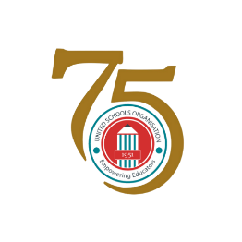

UNITED SCHOOLS ORGANISATION OF INDIA
Empowering Educators Since 1951
CIRCULAR LETTER FOR SCHOOLS

USO INTER-SCHOOLS FEST
Birla Balika Vidyapeeth, Pilani
Saturday, October 31, 2026, 8 AM – 5 PM

